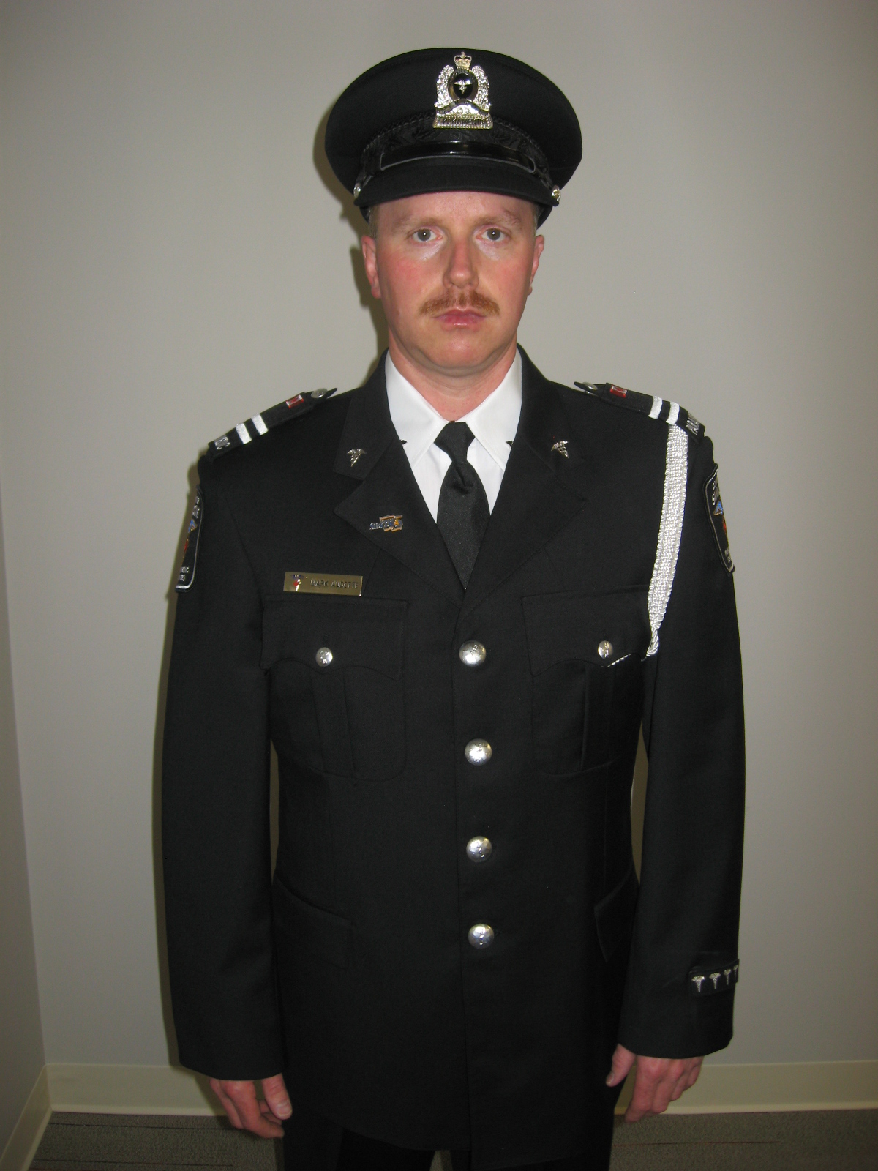

Hat with CSPS badge
Caduceus
(Both sides)
Caduceus
(Both sides)
Epaulette (Both sides)
County of Simcoe Pin
Name Badge
Years of Service
Medals/Decorations
(If applicable)
Lanyard

